# ADO.NET Provider - Installation & Build

This section will guide you how to configure the ADO.NET sdk in .Net Project.

## **Installation on Visual Studio 2019**

* Download the sdk files from this [link](https://drive.google.com/file/d/1EO2a9iZIHyOuxBnC3etQ77js3R8U47td/view?usp=sharing) or copy paste the url to the browser.
* After download we can get the below files in zip:

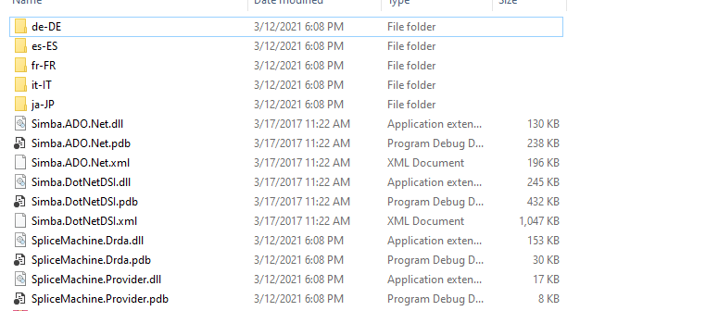

* Paste the extracted files to a secure folder in your project. Refer screenshot below.

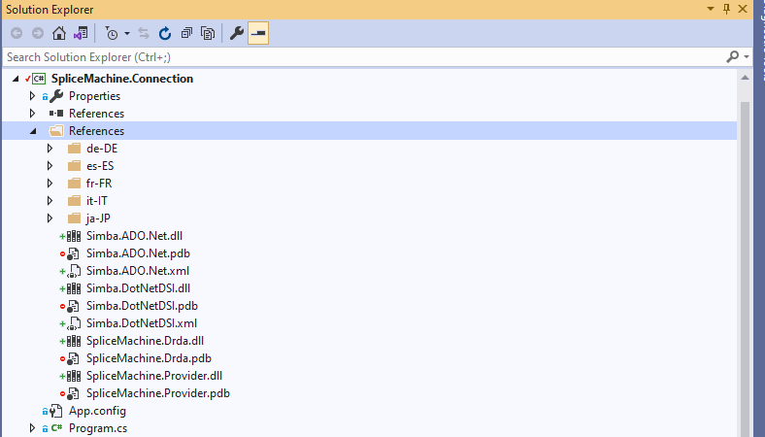

* Right click the references folder and choose Add Reference option.

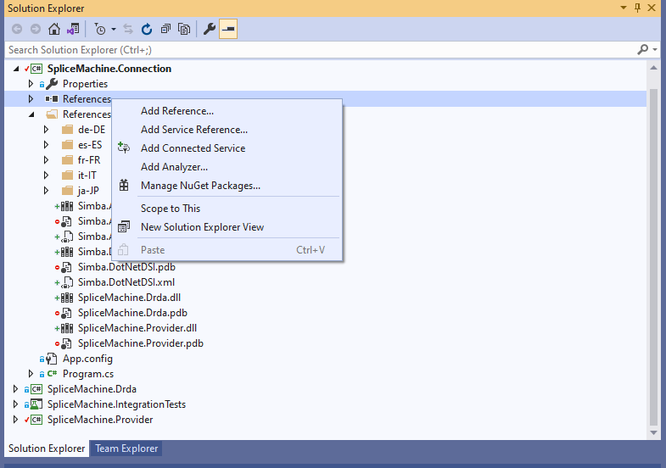

* In the reference manager select Browse and choose the directory where the sdk files loaded.

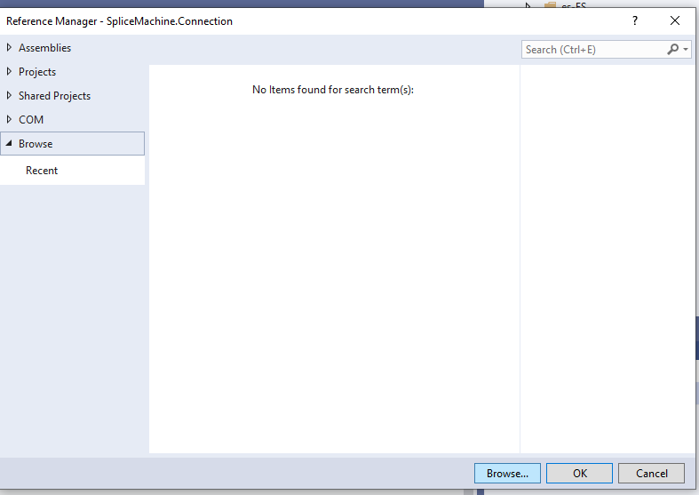

* Select the SpliceMachine.Provider dll and select Add then ok button.

